# Steps for going through the installer w/ test keys

1. Download Installer (provided in Drive account)
2. Drag Installer to Application folder to install
3. If you receive the error:
   1. 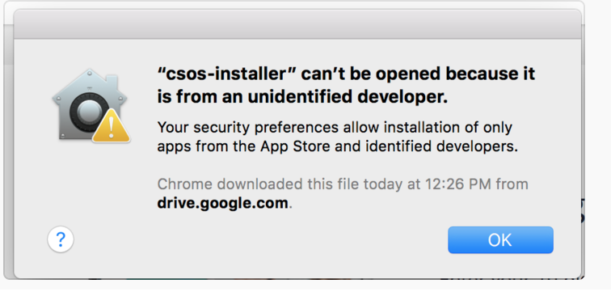
   2. Then go to System Preferences -> Security & Policy and Allow the app downloaded:
   3. 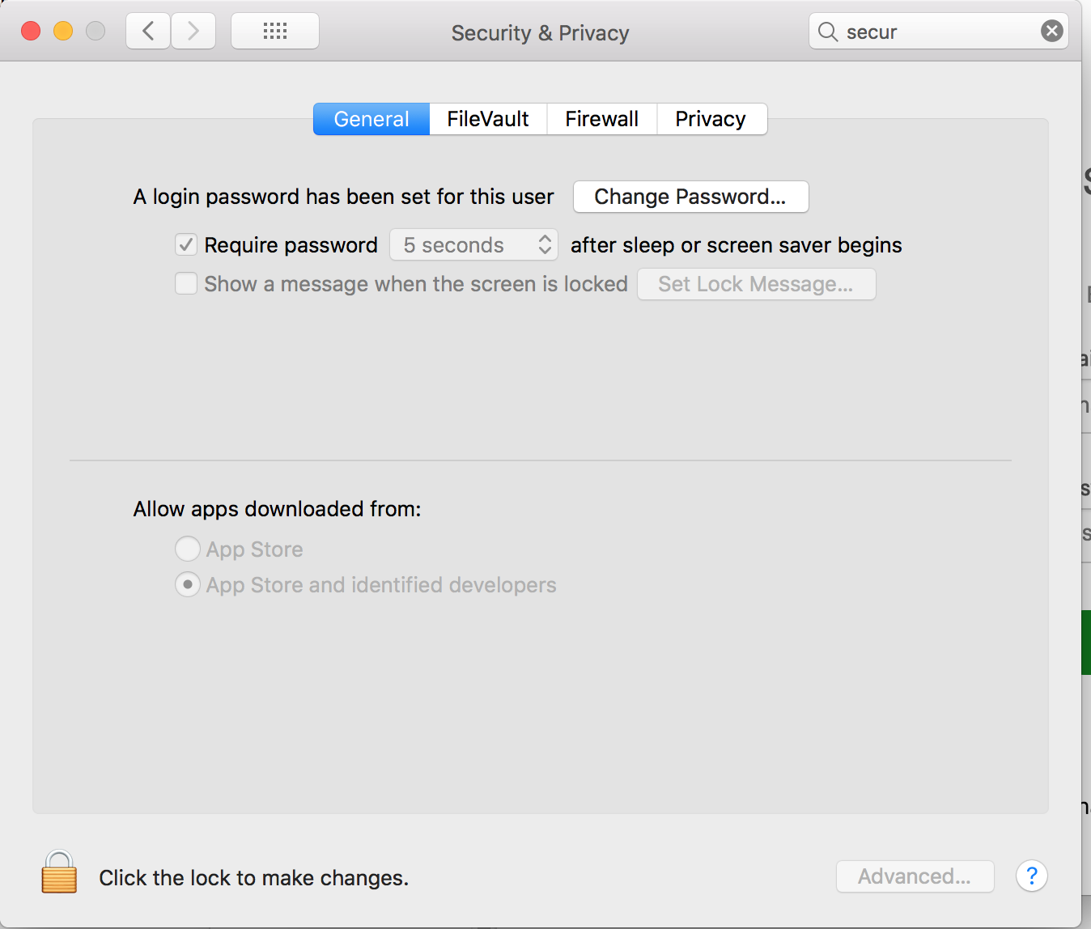
4. On Welcome screen, click the “Sign Up Here” link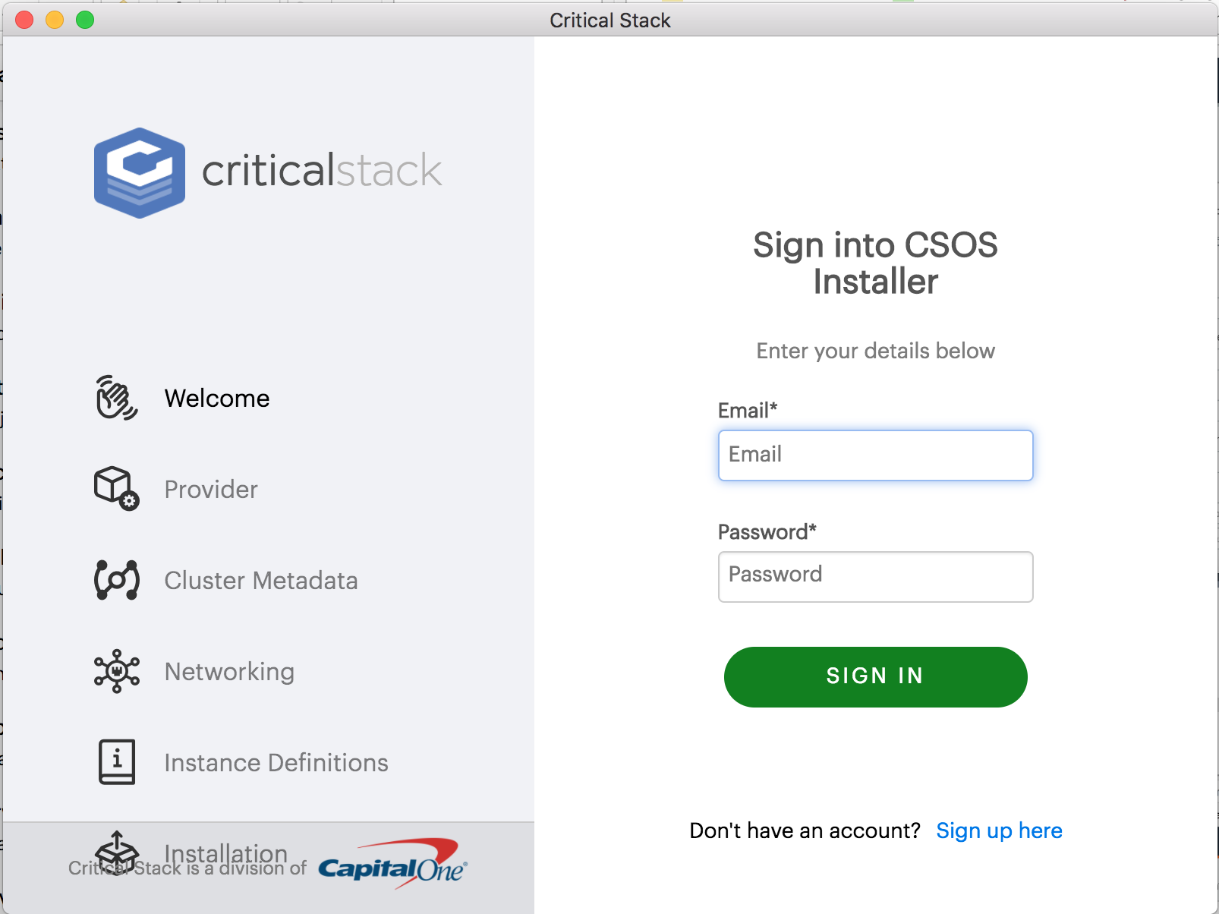
5. Fill in next screen, with license key and corresponding email address:
   1. 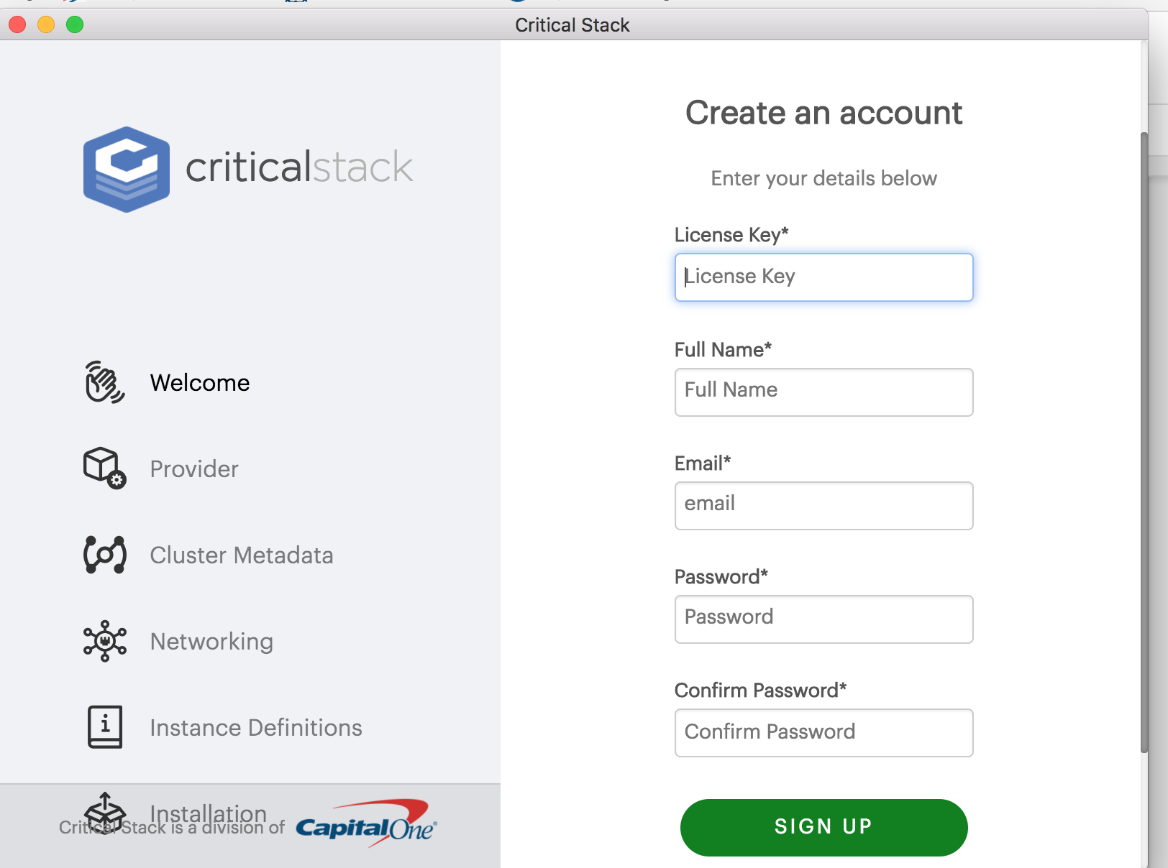
6. **Assuming you have an AWS account already. If not, see the doc “Creating AWS account” at this point, then continue with this set up**
7. On the Provider screen, choose AWS and enter your account information:
   1. 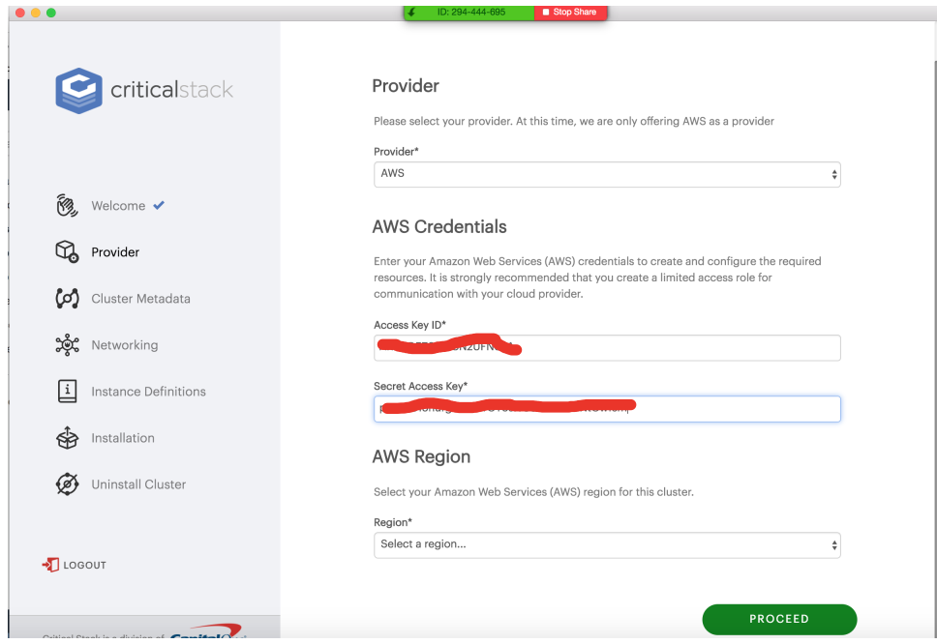
   2. Access Key / Secret must have administrative privileges for setting up the aws assetts
   3. Select the region you want to install to and click proceed
8. On the cluster meta data screen, add any additional tags you want for your aws assetts
   1. 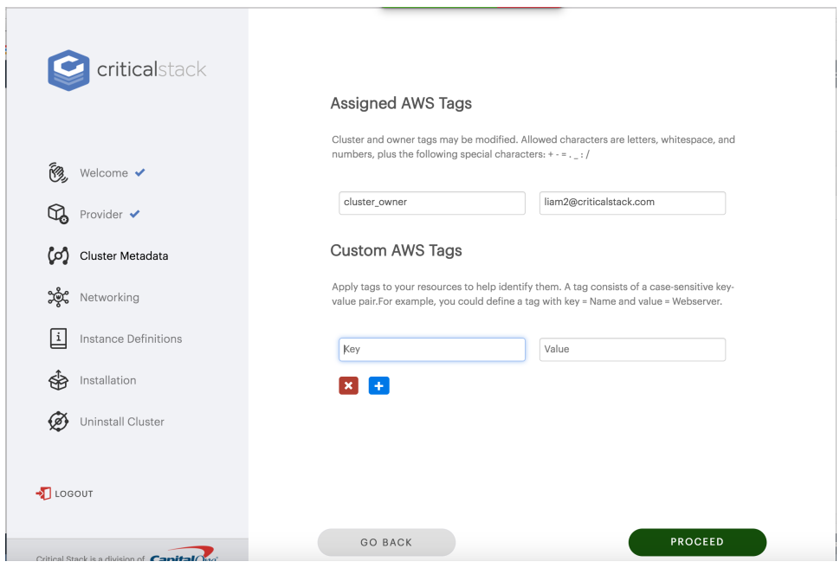
   2. Click proceed
9. Networking, click Next OR if you want to customize you can change to yes to define how you want the cluster installed
   1. 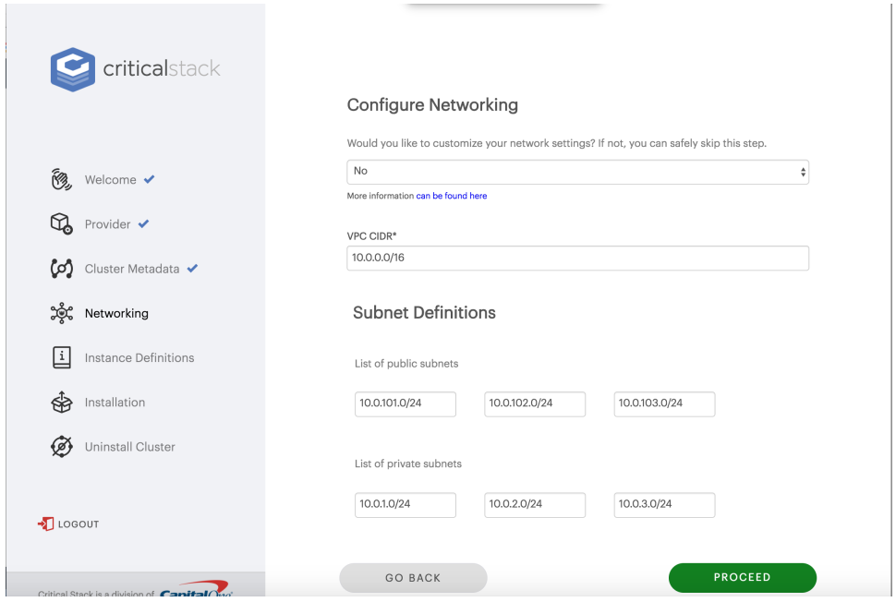
   2. Click proceed
10. Instance Definitions
    1. You can set up any size cluster nodes that you wish.
    2. 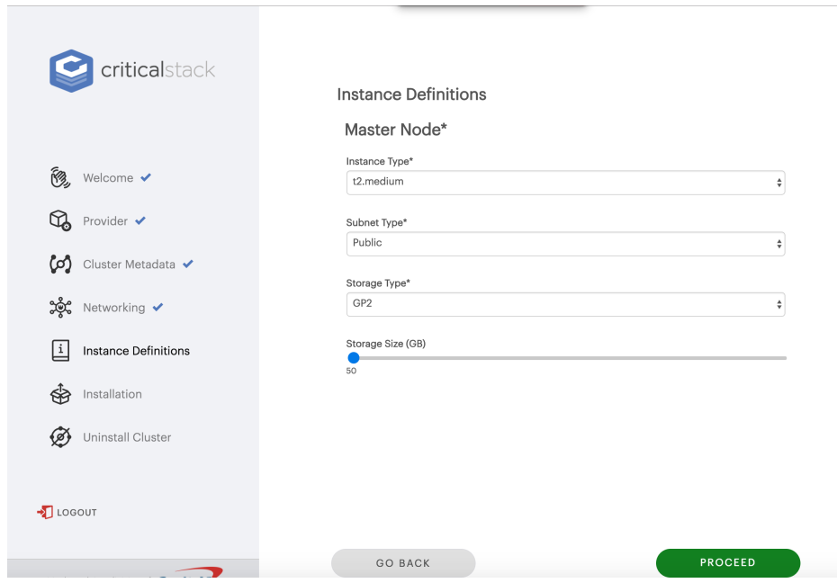
11. CREATE CLUSTER!
    1. 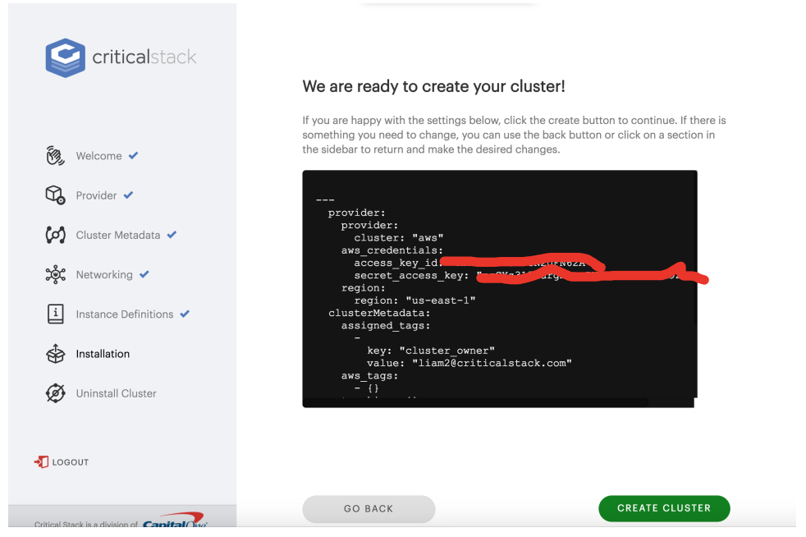
    2. Click Proceed
12. Next step is creating the cluster..this can take several minutes
    1. 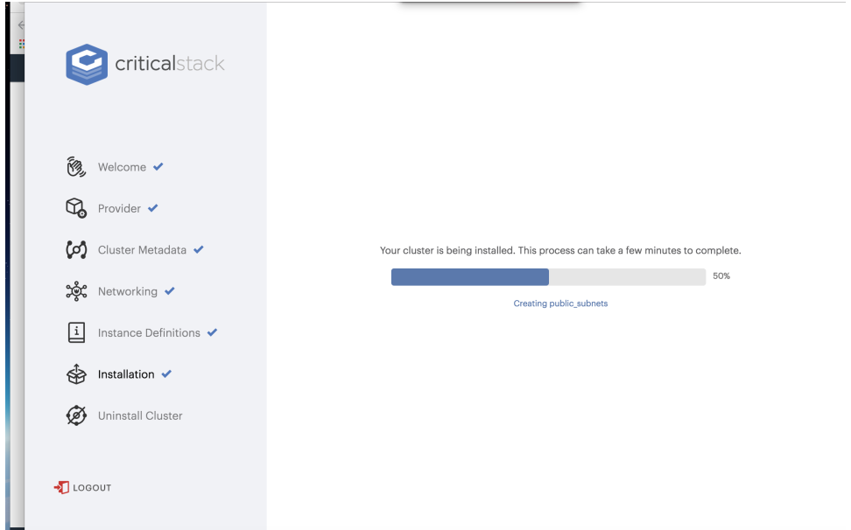
13. Cluster complete!
    1. 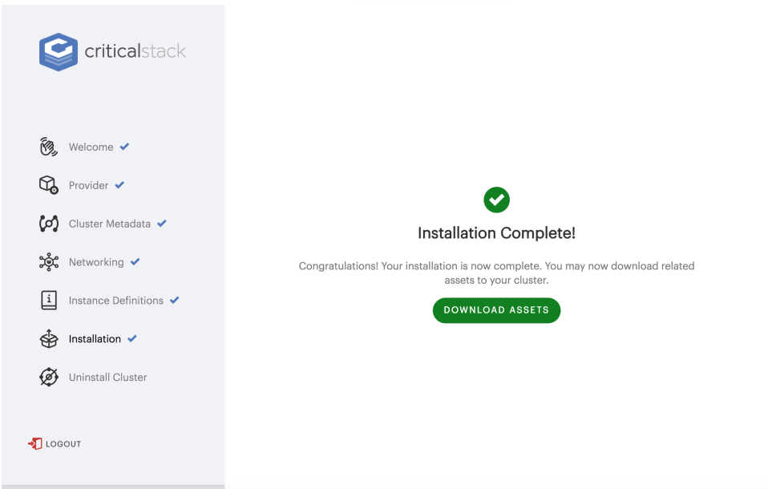
14. Click Download Assets and copy off to a secure location / vault
    1. 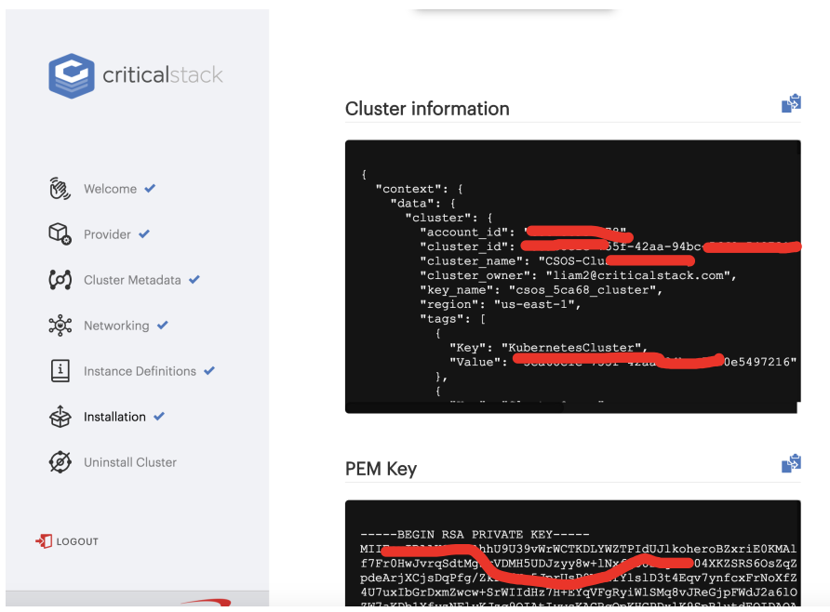
15. Click go to cluster
    1. 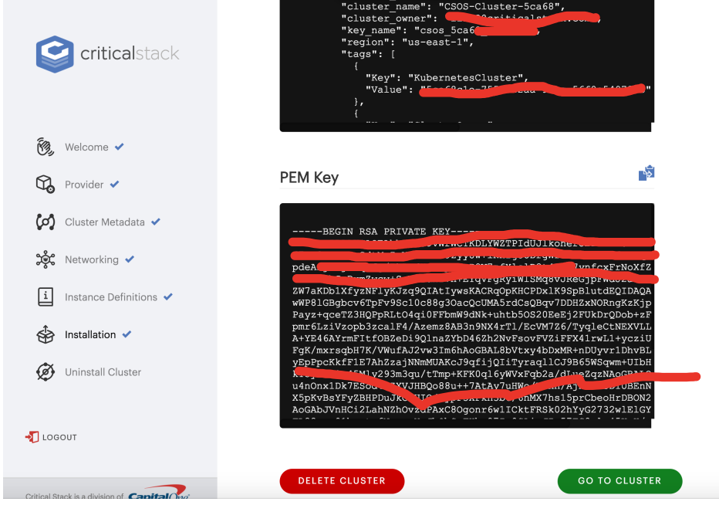
16. 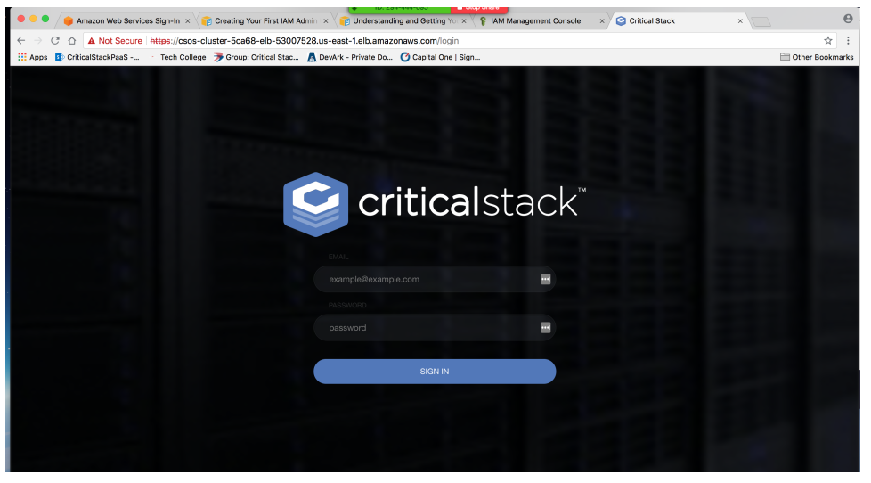
17. Default login is: [dev@criticalstack.com](mailto:dev@criticalstack.com) , password is: ###